**REACT**

**#4**

**Created a new react application using *create-react-app* tool with the name as “blogapp”**

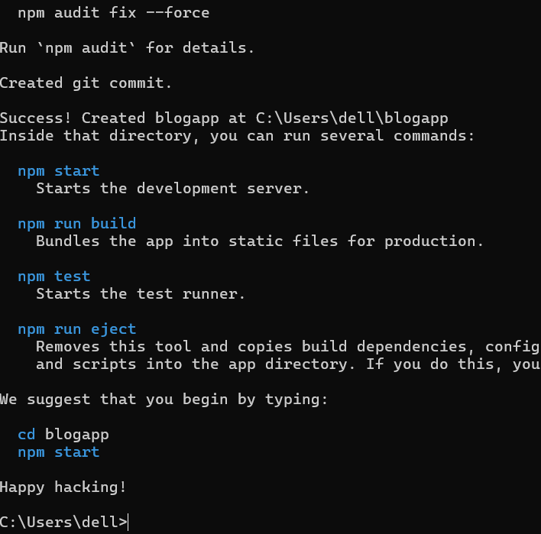

**Created a new file named as Post.js in src folder**

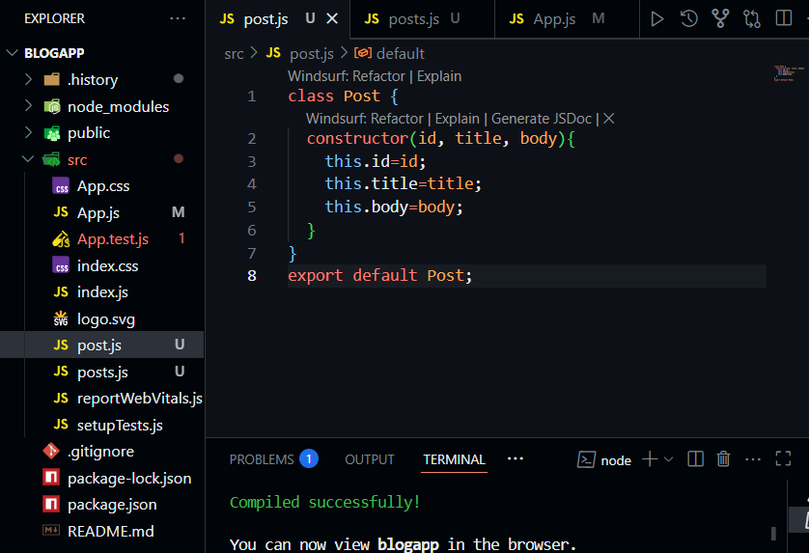

**Create a new class based component named as Posts inside Posts.js file**

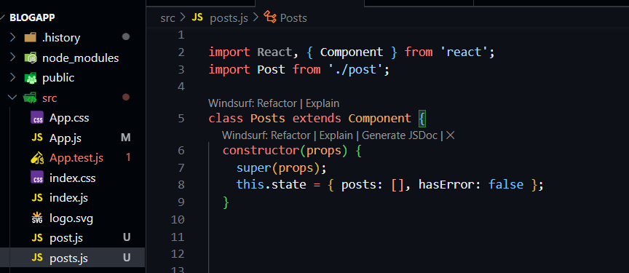

* **Create a new method in component with the name as loadPosts() which will be responsible for using Fetch API and assign it to the component state created earlier. To get the posts use the url (<https://jsonplaceholder.typicode.com/posts>)**
* **Implement the componentDidMount() hook to make calls to loadPosts() which will fetch the posts**
* **Implement the render() which will display the title and post of posts in html page using heading and paragraphs respectively.**
* **Define a componentDidCatch() method which will be responsible for displaying any error happing in the component as alert messages.**

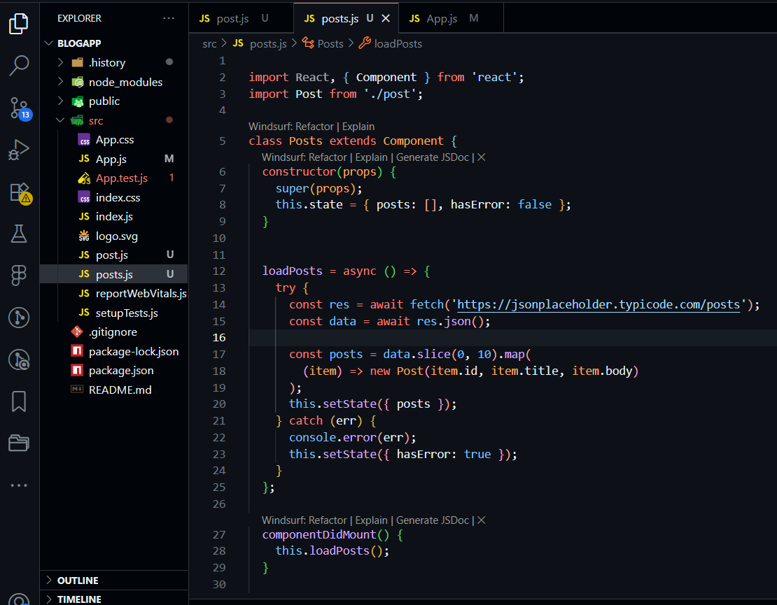

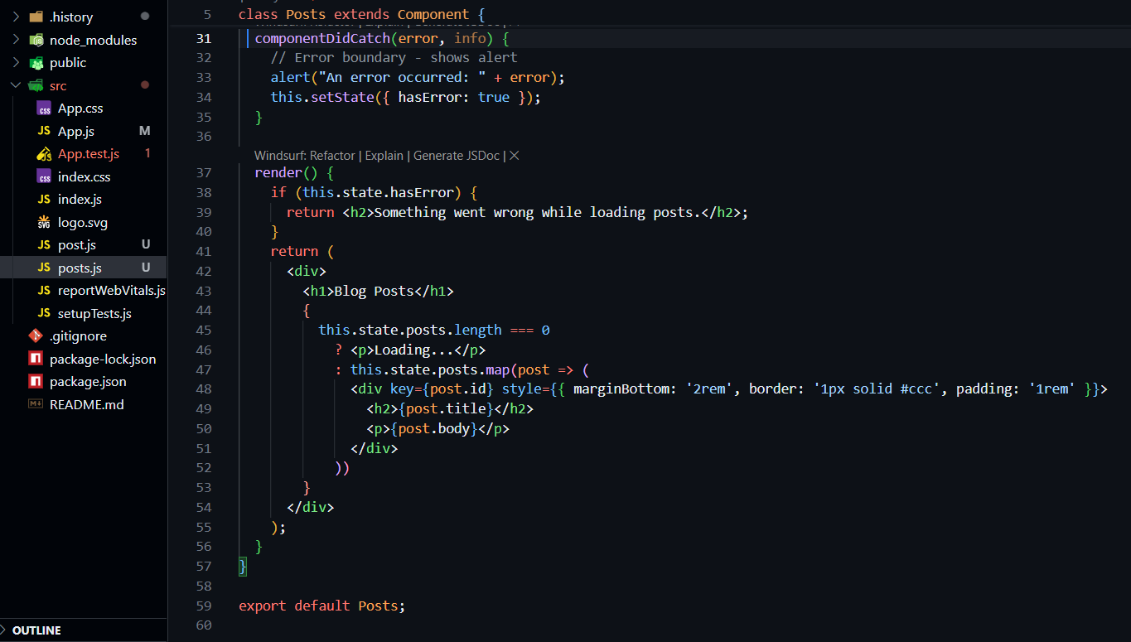

**Add the Posts component to App component.**

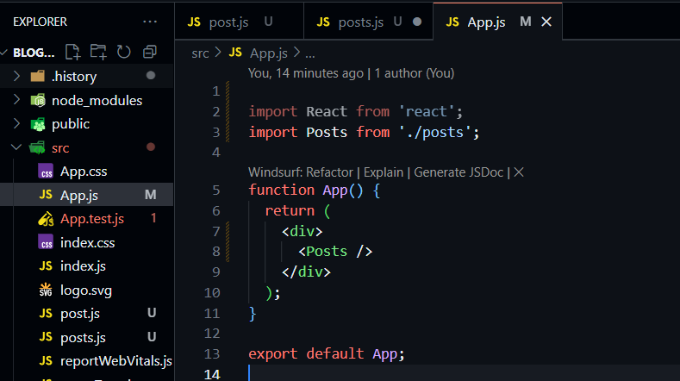

**Built and Ran the application using *npm start* command.**

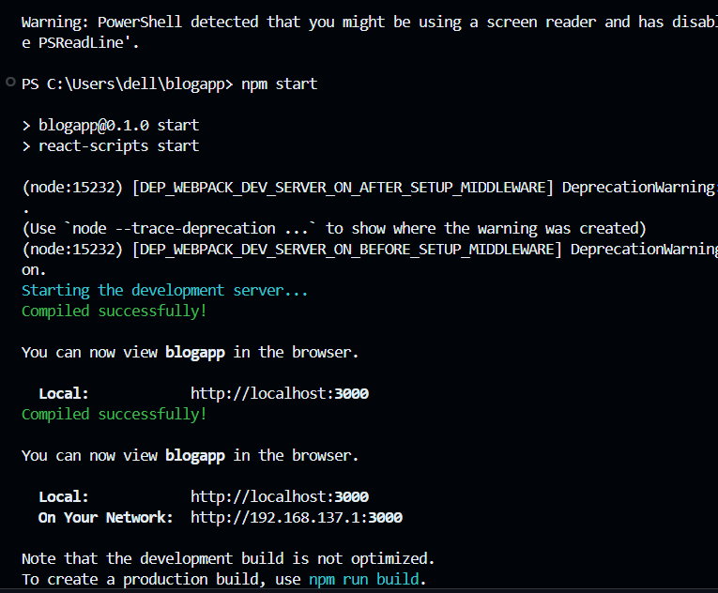

**OUTPUT –**



